|  |
| --- |
| **PROJECT PLANNING & MANAGEMENT FORM**  **CMSE 201**  **GROUP NO : 1**  **PROJECT NAME : Canteen Automation System**  **PROJECT START DATE : 12/11/2020**  **PROJECT END DATE : 12/1/2021**  **SUPERVISOR : Duygu Celik, Selin Bitirim**  **SEMESTER TERM : Fall semester**  Project Type: Software Design & Development Project  Template updated: 20.08.2019 |

A.1. Preliminary Project Information

# A.1.1

|  |  |
| --- | --- |
| **Project No** | 1 |
| **Project Name** | Canteen Automation System |
| **Start Date** | 12/11/2020 |
| **End Date** | 12/1/2021 |
| **Time** | 9.7 weeks |

# A.1.2

|  |  |  |  |
| --- | --- | --- | --- |
| **Project Manager** | | | |
| **Name Surname** | Abdulaziz Binafif | **ID No** | 19701169 |
| **Title/Role** | Project Manager/Lead System Analyst/Lead Programmer | | |
| **Address** | Famagusta/TRNC | | |
| **Phone** | +905338257962 | | |
| **Email** | abdulazizbinafif11@gmail.com | | |

A.2 Group Information

# A.2.1

|  |  |  |  |
| --- | --- | --- | --- |
| **Student 1** | | | |
| **Name Surname** | Hasan Oduncuoğlu | **ID No** | 17330170 |
| **Title/Role** | Network Designer/Tester | | |
| **Address** | Famagusta/TRNC | | |
| **Phone** | 05428725673 | | |
| **Email** | oduncuogluhasan@hotmail.com | | |

|  |  |  |  |
| --- | --- | --- | --- |
| **Student 2** | | | |
| **Name Surname** | Boran Altuntaş | **ID No** | 19331125 |
| **Title/Role** | Database developer/Programmer/Administrator | | |
| **Address** | Famagusta/TRNC | | |
| **Phone** | 05488885022 | | |
| **Email** | borhha22@gmail.com | | |

|  |  |  |  |
| --- | --- | --- | --- |
| **Student 3** | | | |
| **Name Surname** | Ahmad Nedal shahin | **ID No** | 18700959 |
| **Title/Role** | User Interface Designer/Web Developer | | |
| **Address** | Famagusta/TRNC | | |
| **Phone** | +905338410267 | | |
| **Email** | Ahmed.nidal2002@gmail.com | | |

# A.2.2

|  |
| --- |
| **List of Completed / Ongoing Projects of Team** |
|  |

B.1 Introduction to Project

# B.1.1

|  |
| --- |
| **Summary of Project** |
| This Canteen Automation System enables the end users to register online, read and select the food from e-menu card and order food online by just selecting the food that the user want to have using android application. The results after selecting the food from the E-menu card will directly appear in the screen near the Chef who is going to cook the food for you. The system is the combination of Android as well as Web Application. |

# B.1.2

|  |
| --- |
| **Key Words** |
| Android, canteen, application, automation, food ordering, manual system, web application |

# B.1.3

|  |
| --- |
| **Aim of Project** |
| To order food rapidly and to make it convenient for people who have limited time, and also to reduction the cost ,reduced paper work, and to computerized Oder and billing system. |

# B.1.4

|  |
| --- |
| **Innovative Aspects/Contributions of Project** |
| Nowadays people don’t have much time to spend in canteen by just there and waiting for the waiter to take their order. Many customer visits the canteen in their lunch break and recess so they have limited time to eat and return to their respective office and colleges. So this software helps them to save time and order food whenever they want without calling the waiter again and again. |

# B.1.5

|  |
| --- |
| **Methods to be Applied** |
| Data collection method (interview)  UML diagrams  Unit testing  System development |

# B.1.6

|  |
| --- |
| **Economic and National Outcomes** |
| This system greatly simplifies the ordering process for both the customer and the canteen, and also it reduced the cost and paper work. |

B.2 Reason of Starting the Project, Methods and R&D Stages

# B.2.1

|  |
| --- |
| **1- Explain the reason of starting this project. (Max 500 character)** |
| Because it lightens the load on the canteen’s end, as the entire process of taking orders is automated, and this allows canteen employees to quickly go through the orders as they are placed and produce the necessary items with minimal delay and confusion. |

|  |
| --- |
| **2- Explain the purpose of this project.** |
| Improve the purchasing process for both the client and the canteen and to make it easier and this software helps the customers to save time and order food whenever they want without calling the waiter again and again. |

|  |
| --- |
| **3- Explain**   * **output of project** * **national / international standards if exist** * **the specific objectives of the project** * **success criterias** * **realistic constraints** |
| We aim at the end of this project to save customers’ time. Our project can be applied in restaurants and cafeterias, est. At the end of this project we will improve the ordering process for both the customer and the canteen. For the project to be successfu, we need to enables the end users to register online, read and select the food from e-menu card and order food online by just selecting the food that the user want to have using android application. |
| **4- Explain**   * **the methods to be applied during R&D activities** * **applications** * **technics and tools to be used** * **standards to be followed under the workflow** |
| ***Which SOFTWARE PROCESS MODEL in below will you apply? Why? How? Explain.***  ***\* The waterfall model?***  ***\*V-model of software process?***  ***\*Evolutionary development?***  ***\*Component-based software engineering? Etc.***  We will use Incremental RAD model because it’s advisable where requirements are clear and the development time is less. The striking feature of the incremental model is that each module can be completed and released as and when the requirement arises because of lack of time. As in our system, many of the modules are not inter-related so can be released in isolation. The user can thus get a feel of these modules and give his feedback which can be utilized for making the software more user-friendly and in line with the user requirements.  **Explain, Project Workflow:**   1. **Feasibility and Pre-research:**   The feasibility study is not a full-blown systems study. Rather, the feasibility study is used to gather broad data to make a decision on whether to proceed with system study, and It’s dependent on the humans who will be using the software once it’s ready and installed for use. The software will have a user-friendly interface which will be much convenient as compared to the current manual procedure. Thus the project is operationally feasible.   1. **System Design:**   We will use Case diagram to describes a task or a series of tasks that users will accomplish using the software and includes the responses of the software to user actions, and we’ll use Class diagram to describes the structure of a system by showing the system's classes, their attributes, and the relationships between the classes, sequence diagram to shows how processes operate with one another and in what order, and ER diagram to use symbols to represent three different types of information.   1. **Software development:**   In our system, many of the modules are not inter-related so can be released in isolation. The user can thus get a feel of these modules and give his feedback which can be utilized for making the software more user-friendly and in line with the user requirements.   1. **Prototype implementation and testing work:**   The system will be developed using PHP, HTML, CSS and other Web tools, and the product developed will provide an easy access to the user to manage and alter the canteen automation according to the need.   1. **Maintenance:**   These systems store all of their critical data and allow for easy maintenance in some cases. The Structured Query Language (SQL) is a very popular database language, and its standardization makes it quite easy to store, update and access data, also maintenance tools are currently inadequate for maintaining server libraries. |
| **5- Explain**   * **the contribution of national/international technological development if exist** * **starting a new research and development projects within or outside the team** * **launch new applications or research studies in different technology areas**   **With whom we can cooperate?**  **Expectations:**  **Published work:**  **Can your output be an input for other similar national/international projects?** |
| For the spread of the project it's possible to communicate with restaurants, cafeterias and establish a business partnership. This project can be developed as a web-based application, also within this application, all items in the order are displayed, along with their corresponding options and delivery details, in a concise and easy to read manner. |

B.3 Innovative and Unique Aspects

# B.3.1

|  |
| --- |
| **1- Describe**   * **differences** * **advantages** * **superiority**   **Compared to other similar projects.** |
| Our best benefit, according to similar projects, is to be built according to the users' wishes and to be perfect and modular, since other projects have set patterns and everyone has to use them according to the project guidelines. Changeability will be available in our project depending on the requirements and needs. |

# B.4.1

|  |
| --- |
| **2- Who can contribute to this project in your team?** |
| * Project Manager * System Designer * Database Developer * Interface Designer * Lead Programmer * Network Designer-Tester |

C.1 Gantt Chart and Work Packages

# C.1.1 Gantt Chart

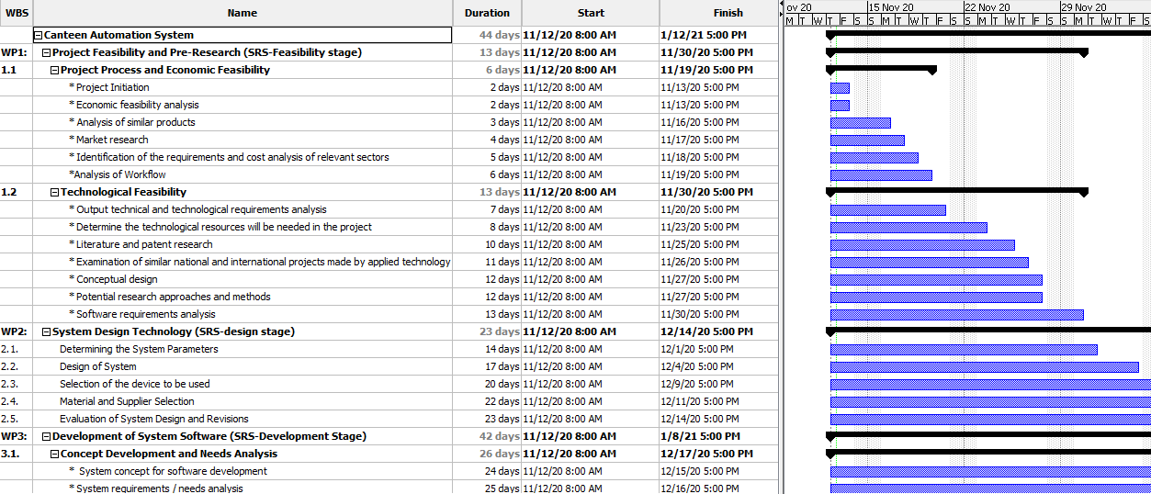

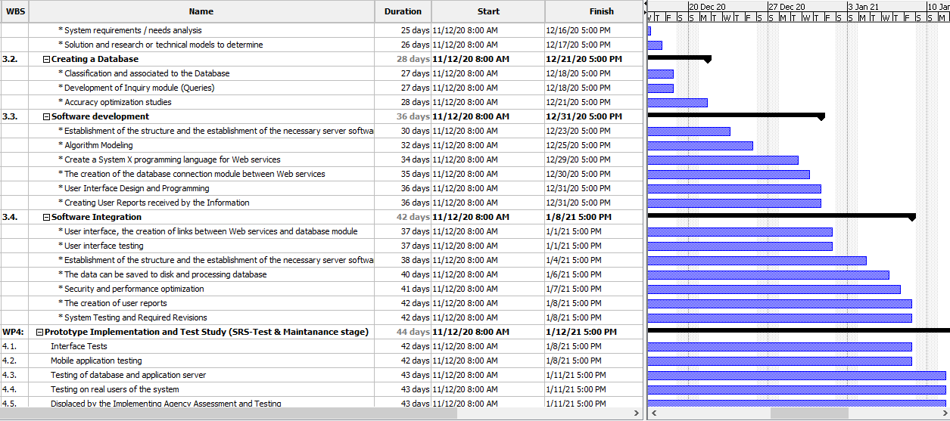

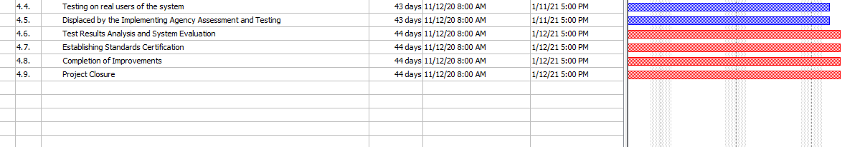

# Pert Analysis and Network Diagram:

|  |  |  |  |  |
| --- | --- | --- | --- | --- |
| **Work Package Name** | **Optimistic Time** | **Realistic Time** | **Pessimistic Time** | **Expected Time ((o+4r+p)/6)** |
| **Project Feasibility and Pre-Research (SRS-Feasibility stage)** | **9 days** | **12 days** | **21 days** | **13 Days** |
| **System Design Technology (SRS-design stage)** | **7 days** | **10 days** | **13 days** | **10 Days** |
| **Development of System Software (SRS-Development Stage)** | **14 days** | **19 days** | **22 days** | **18.67 Days** |
| **Prototype Implementation and Test Study (SRS-Test & Maintenance stage)** | **1 days** | **2** **days** | **3 days** | **2 Days** |

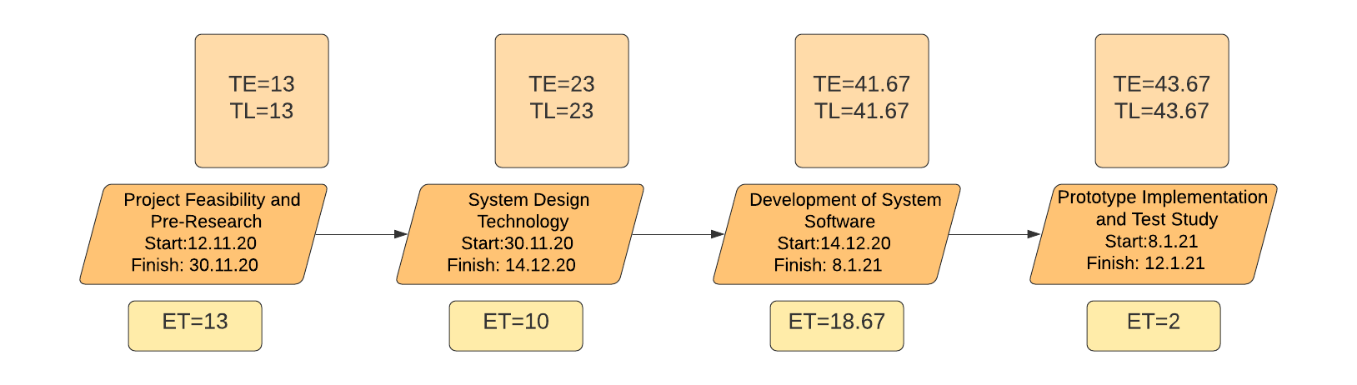

# C.1.2 List of Work Packages

|  |  |
| --- | --- |
| **Work Package No** | 1 |
| **Work Package Name** | **Project Feasibility and Pre-Research (Feasibility Analysis)** |
| **Start-End Date and Time** | 12/11/2020 – 30/11/2020 (2 Weeks) |
| **Related Organizations** | - |

|  |
| --- |
| **1- List the activities of work packages.** |
| **1.1 Project Process and Economic Feasibility:**  **\* Project Initiation**  **\* Economic feasibility analysis**  **\* Analysis of similar products**  **\* Market research**  **\* Identification of the requirements and cost analysis of relevant sectors**  **\*Analysis of Workflow**  **1.2 Technological Feasibility:**  **\* Output technical and technological requirements analysis**  **\* Determine the technological resources will be needed in the project**  **\* Literature and patent research**  **\* Examination of similar national and international projects made by applied technology**  **\* Conceptual design**  **\* Potential research approaches and methods**  **\* Software requirements analysis** |
| **2- Describe the methods and parameters that will be used for work package.** |
| In this work package, technical, legal, operational and schedule feasibility strategies will be used. |
| **3- List the experiments, tests and analysis in the work package.** |
| * Economic market and outcomes test * Technological requirements and users’ needs test * Project process flow test |
| **4- List the output of work package and its success criterias.** |
| **Outputs:**  The output of feasibility study is to show similar projects’ market space and missing features.  **Success Criterias:**  If current system have little usability and features, our project will deserves working on it. |
| **5- Explain the relation of output with other work packages** |
| Other work packages are needed for this feasibility work package, so we can only start working on other work packages after this work package is successfully completed. |

|  |  |
| --- | --- |
| **Work Package No** | 2 |
| **Work Package Name** | **Based System Design Technology (Analysis & Design stage)** |
| **Start-End Date and Time** | 30/11/2020 – 14/12/2020 (10 days) |
| **Related Organizations** | - |

|  |
| --- |
| **1- List the activities of work packages.** |
| * **Determining the System Parameters** * **Design of System** * **Selection of the device to be used** * **Material and Supplier Selection** * **Evaluation of System Design and Revisions** |
| **2- Describe the methods and parameters that will be used for work package.** |
| * Figuring out system architecture with this work package * Research about the most useful methodologies that suit the project |
| **3- List the experiments, tests and analysis in the work package.** |
| * Research about convenient development interface * Research about coding language * Research about application of system architecture to the project |
| **4- List the output of work package and its success criterias.** |
| **Outputs:**  The most important output is fully ready system architecture for development stage.  **Success Criterias:**  Convenient models and methodologies. |
| **5- Explain the relation of output with other work packages** |
| Before starting development and implementation steps, the most important thing is that system design/architecture reach success at next steps of the project. |

|  |  |
| --- | --- |
| **Work Package No** | 3 |
| **Work Package Name** | **Development of System Software (SRS-Development Stage)** |
| **Start-End Date and Time** | 14/12/2020 - 8/1/2021 (19 days) |
| **Related Organizations** | - |

|  |
| --- |
| **1- List the activities of work packages.** |
| * + - **Concept Development and Needs Analysis**     - **Creating a Database**     - **Software development**     - **Software Integration** |
| **2- Describe the methods and parameters that will be used for work package.** |
| * Creating relational database with ER and different types of diagrams * Using pre-desired software language and platform |
| **3- List the experiments, tests and analysis in the work package.** |
| * Start time for coding * Little unit tests for strong codes * Integration with IDE, DB * Interface design with professional tools |
| **4- List the output of work package and its success criterias.** |
| **Outputs:**   * Running sample application of the project * Ready to test the codes   **Success Criterias:**  Low error rate in coding step.  Effective database design and implementation. |
| **5- Explain the relation of output with other work packages** |
| As other work packages are preparatory for this phase, the project is completely linked to this work package. Only testing and releasing steps will occur after this work package. |

|  |  |
| --- | --- |
| **Work Package No** | 4 |
| **Work Package Name** | **Prototype Implementation and Test Study and Maintenance (SRS-Test &Maintenance stage)** |
| **Start-End Date and Time** | 8/1/2021 – 12/1/2021 |
| **Related Organizations** | - |

|  |
| --- |
| **1- List the activities of work packages.** |
| * **Interface Tests** * **Mobile application testing** * **Testing of database and application server** * **Testing on real users of the system** * **Displaced by the Implementing Agency Assessment and Testing** * **Test Results Analysis and System Evaluation** * **Establishing Standards Certification** * **Completion of Improvements** * **Project Closure** |
| **2- Describe the methods and parameters that will be used for work package.** |
| * Database testing * Interface testing by all team members * Testing real users’ opinions about the project and usability |
| **3- List the experiments, tests and analysis in the work package.** |
| Unit test will be completed and correcting errors if there exist, unit test is the most important test for project release step. |
| **4- List the output of work package and its success criterias.** |
| **Outputs:**   * Reporting test results. * Ready to release the project.   **Success Criterias:**  The application should be passed from all tests perfectly. |
| **5- Explain the relation of output with other work packages** |
| This work package is the last one. So, if this work package’s steps will be perfectly completed, our project will be done. It means the project is ready to release market and gain. |

# C.1.3 List of Milestones (should be matched in the Gantt chart)

|  |  |  |
| --- | --- | --- |
|  | **Description of Output** | **Expected Time Interval** |
| ***Example:*** | ***Feasibility Studies*** | ***01.07.2014 – 30.09.2014*** |
| 1 | Project Feasibility and Pre-Research (SRS-Feasibility stage) | 12/11/2020 - 30/11/2020 |
| 2 | System Design Technology (SRS-design stage) | 30/11/2020 – 14/12/2020 |
| 3 | Development of System Software (SRS-Development Stage) | 14/12/2020 – 8/1/2021 |
| 4 | Prototype Implementation and Test Study (SRS-Test & Maintenance stage) | 8/1/2021 – 12/1/2021 |

# C.1.4 List of Risks *(see the following example; write possible risks for your project!)*

|  |  |  |  |
| --- | --- | --- | --- |
| Risk | Probability | Effects | Your Strategy |
| The time required to develop the software is underestimated. | High | Serious | With correctly configured work delivery and continuous team sessions, it is possible to resolve. |
| Software tools cannot work together in an integrated way. | High | Tolerable | New tools for manual use or combined uses can be found. |
| Customers fail to understand the impact of requirements changes. | Moderate | Tolerable | Changing demands with new understandable demands depends on requirements. |
| The rate of defect repair is underestimated. | Moderate | Tolerable | Replace potentially defective components with more reliable bought-in components. |
| The size of the software is underestimated. | High | Serious | Investigate buying sw components;  Investigate use of a program generator. |
| Code generated by code generation tools is inefficient. | Moderate | Insignificant | Code can be written in various languages, on different compilers. |
| Key staff are ill at critical times in the project. | Moderate | Serious | Reorganize team so that there is more overlap of work and people therefore understand each other’s jobs. |
| The database used in the system cannot process as many transactions per second as expected. | Moderate | Serious | Investigate the possibility of buying a higher-performance database. |

C.2 Project Management and Organization

# C.2.1 Project Team

|  |  |  |  |  |  |  |
| --- | --- | --- | --- | --- | --- | --- |
| **Personnel Name** | **Title** | **ID** | **Education Status** | **Graduation Date** | **Date of Starting Work** | **Idea Owner** |
| Abdulaziz Binafif | Project Manager | 19701169 | B.S. | 2023 | 12.11.2020 |  |
| Ahmad Nedal Shaheen | User Interface Designer | 18700959 | B.S. | 2023 | 12.11.2020 |  |
| Boran Altuntaş | Database Developer | 19331125 | B.S. | 2023 | 12.11.2020 |  |
| Hasan Oduncuoğlu | Network Designer /Tester | 17330170 | B.S. | 2022 | 12.11.2020 |  |

# C.2.2 Organization Scheme (an example is given below!)

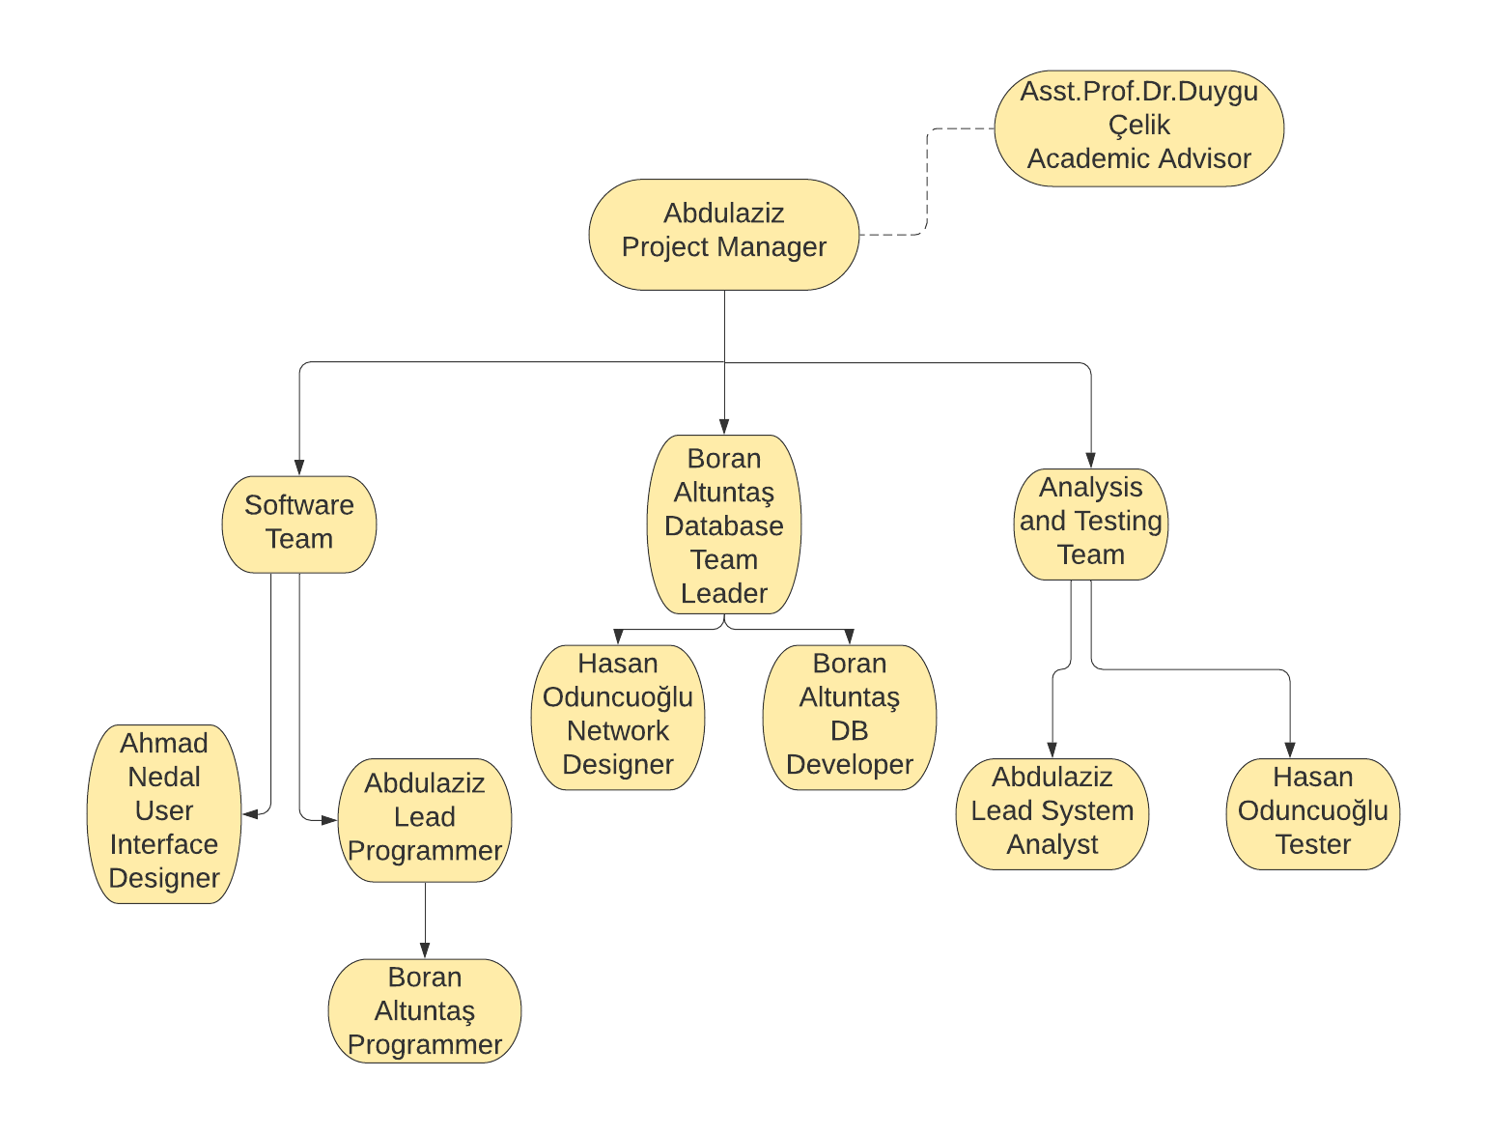

D.1 Economic Forecasts

|  |
| --- |
| **1- Evaluate the commercialization potential of project outcomes. List possible risks here?** |
| The organization has evaluated the cost of software and hardware required for the system including the storage of data. The benefits expected from the system are studied to assess the reduced cost due to the new system. |

|  |  |
| --- | --- |
| **2- List your expectations to your team which are come by your project** | |
| Time-to-market (month): | The beginning of December |
| The expected increase in sales revenue (%): | 5 |
| The expected increase in market share (%): | 10 |
| Time to start to gain: | May 2021 |

D.2 National Outcomes

|  |
| --- |
| **1- Specify the output that may be subject to patent, utility model and industrial design registration in the project.** |
| For each restaurant / cafeteria, we will adapt our project accordingly. For each restaurant/cafeteria, we will create distinct industrial designs according to incoming requests. |
| **2- Explain the potential of project and its outputs that may have an effect on social life, education, health and etc.** |
| This project would have an impact on social life, as the project is meant to save time for consumers, and would have an impact on their lives. |
| **3- Explain the positive and negative effects of project outputs for environment and human being.** |
| * Positive effects: Completely automated online ordering of food in a canteen, order can be placed using personal android phones, food ordering pages that look and feel exactly the same as the existing restaurant website. * Negatives effects: Requires an active internet connection, requires Android phone if user is ordering. |

(M013) Instrument / Equipment / Software / RELEASE PURCHASES

|  |  |  |  |  |  |  |  |  |  |  |  |
| --- | --- | --- | --- | --- | --- | --- | --- | --- | --- | --- | --- |
| **Project Name** | |  | | | | | | | | | |
| **Line no** | **Instrument / Equipment / Software / Publication Name** | | **No. of Item** | **Capacity** | **Technical specification** | **Purpose of Project Activities** | **Post-Project Place of Use / Purpose** | | **Unit Price (USD)** | **Unit Price (TL)** | **Total Amount (TL)** |
| **R & D** | **Production** |
| **1** | Laptop | | 1 |  | Min, i3 - 1gb | Coding | Coding | Coding | 800 $ | 6100 TL | 6100TL |
| **2** | Internet Connection | | 1 |  |  | Connection | Research/ testing | Communication | 55 $ | 420 TL | 420 TL |
| **3** | Android Device | | 1 |  | Min, Android 4 | Emulation | Emulation | Test | 80 $ | 610 TL | 610 TL |
| **4** | Printer | | 1 |  | HP | Printing out | Documentation | Documentation | 100 $ | 765 TL | 765 TL |
| **5** |  | |  |  |  |  |  |  |  |  |  |
| **6** |  | |  |  |  |  |  |  |  |  |  |
| **7** |  | |  |  |  |  |  |  |  |  |  |
| **8** |  | |  |  |  |  |  |  |  |  |  |
| **9** |  | |  |  |  |  |  |  |  |  |  |
| **10** |  | |  |  |  |  |  |  |  |  |  |
|  |  | |  |  |  |  |  |  |  | 1035 $  **TOTAL** | 7895 **TL** |

(M030) Quarterly Estimated Cost Form (TL)

|  |  |  |  |  |
| --- | --- | --- | --- | --- |
| **Project Name :** | | | | |
| **Cost Item** | **2019-2020** | | **TOTAL**  **(TL)** | **TOTAL COST RATE OF CONTENTS (%)** |
| **I** | **II** |
| **Personnel** | 50.000 | 50.000 | 100.000 | 89,48% |
| **Travel** | 2.500 | 2.500 | 5.000 | 1,52% |
| **Instrument / Equipment / Software / Publications** | 10.000 |  | 10.000 | 9% |
| **Domestic Works Made By R & D and Testing Institutions** |  |  |  |  |
| **International Works Made By R & D and Testing Institutions** |  |  |  |  |
| **Domestic Services Procurement** |  |  |  |  |
| **Overseas Service Procurement** |  |  |  |  |
| **Material** |  |  |  |  |
| **TOTAL COST** | 62.500 | 52.500 |  | 100 |
| **CUMULATIVE COST** |  |  | 115.000 | 100 |
| **IN THE PROJECT TOTAL MAN-MONTH** | | | 115.000 | |

APPENDIX

1. Perform estimation of effort (Man/month), required total time duration and required number of team members by using COCOMO approach (or other methods are possible).
2. CPM (Critical Path Management) analysis by using PERT (defining paths)
3. Creating network diagram of the main tasks in WBS
4. Calculating probability of successful completion rate for each path
5. Crashing approach, etc. techniques and the results can be written here.

**By using basic COCOMO in organic mode:**

**Our used language is SQL (21)**

**KLOC= (FP*loc)/1000**

**= (377*21)/1000 -> 7.917**

**Effort= 2.4*(7.917)^1.05 = 21.07**

**Duration= 2.5*(7.917)^0.38 = 5.49**

**Number of team members= Effort/Duration**

**= 21.07/5.49**

**=3.84 Person required**

|  |  |  |
| --- | --- | --- |
| **Tasks** | **Predicates** | **Expected Time** |
| A | - | 6 |
| B | A | 7 |
| C | A | 10 |
| D | C | 3 |
| E | B,C | 2 |
| F | D,E | 8 |
| G | E | 6 |
| H | F | 2 |

|  |  |  |
| --- | --- | --- |
| **Paths** | **Calculations** | **Expected time for each path** |
| ABEFH | 6+7+2+8+2 | 25 |
| ABEG | 6+7+2+6 | 21 |
| ACEG | 6+10+2+6 | 24 |
| ACEFH | 6+10+2+8+2 | 28 |
| ACDFH | 6+10+3+8+2 | 29 |

**ACDFH is the critical path.**



